Willow Westbrook
Professor Mee
ISOM-230
Term Project

Benchmark 1:
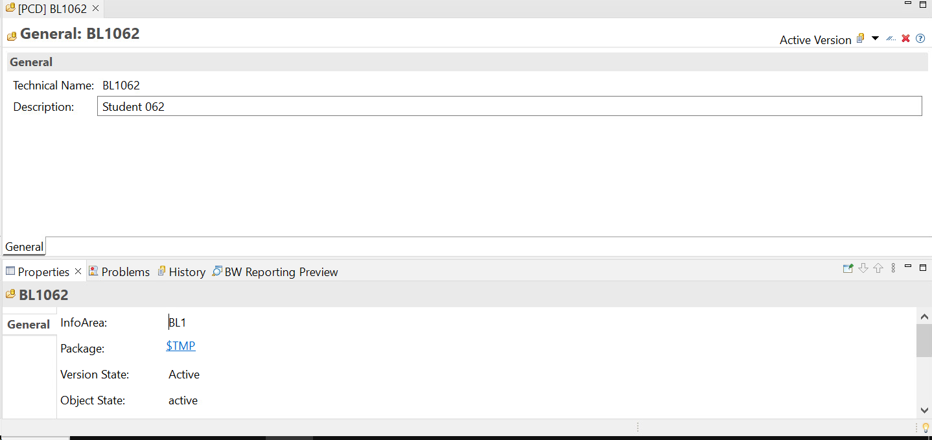
Question 1: My InfoArea technical name is BL1062, the description is my assigned student number.
Question 2: You are not allowed to edit or delete objects in the MU0 InfoArea.
Question 3: You are not allowed to edit or delete objects in InfoAreas that do not belong to you.
Question 4:
Customers:
- Sales organization
- Currency key
- Customer
Measures:
- Net sales
- Sales quantity
- Revenue
- Discount
- Cost of goods manufactured.
Order:
- Order number
- Order Item
Product:
-unit of measure
-material
Time:
- Calendar month
- Calendar year/month
- Calendar year
- Calendar day

Benchmark 2:
- A data source is a place or system where data can be pulled from to use in
- In terms of snowflake schema, the destination of the data would involve structuring the data into a central fact table that is surrounded by normalized dimension tables. Using the snowflake schema allows you to normalize dimension tables which helps you avoid redundant data and ensure consistency across the entire database.
- The revenue format when looking at the data preview shows only the internal format of the data and does not have any thousand separators.
- The internal format for sales date is year, month, and day.
- The difference in the US and Germany data is what currency it is in.
- We made a data source for the US and Germany data because the data is different, but in the same file structure.
- The unit measure of sales quantity is quantity.
Benchmark 3:
Benchmark 4:

